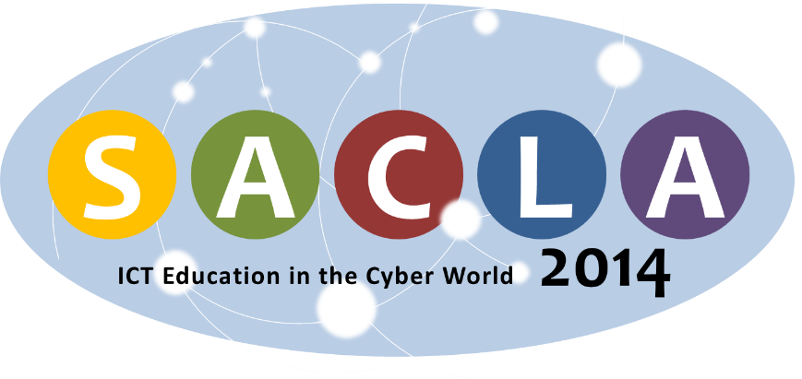

SACLA 2014 REGISTRATION FORM
Please complete and return this form along with proof of payment by latest
Friday, 30 May 2014 to:
Fax: (+27) 041 504 2831 | E-mail: sacla2014@nmmu.ac.za

YOUR CONTACT DETAILS
TITLE | ☐Mr ☐Ms ☐Dr ☐Prof |  |  |  |  |  |  |  | Other (please specify) ________________________
LAST NAME |  |  |  |  |  |  |  |  | FIRST NAME
organisation
Address
Suburb/town
province |  |  |  |  |  |  |  | country |  |  |  |  | postcode
Work phone |  |  |  |  |  |  |  |  | mobile
email
REGISTRATION
Early Bird |  | ☐ |  |  | R2 600 |  | Early bird registration ends on Wednesday, 14 April 2014
Normal |  | ☐ |  |  | R 3 000 |  | The final date of registration is on Friday, 30 May 2014
hod colloquium |  | ☐ |  |  | No cost
Blended Learning workshop |  | ☐ |  |  | R 750
DIETARY REQUIREMENTS
☐None |  |  |  |  |  | ☐Vegetarian |  |  |  |  |  | ☐Halaal
I have an allergy to
METHOD OF PAYMENT: BANK DEPOSIT
bank |  |  | Standard Bank
account name |  |  | Nelson Mandela Metropolitan University – Main Account
branch number |  |  | 050417
account number |  |  | 080 263 011
reference |  |  | SACLA 2014 EB73.4275 + YOUR SURNAME
REGISTRATION PROCEDURE
- Deposit the registration fee amount into the NMMU bank account listed in the section above. Remember to include the reference number together with your surname.
- Complete and return this form along with proof of payment by latest Friday, 30 May 2014 to:
  - Fax: (+27) 041 504 2831, or
  - E-mail: sacla2014@nmmu.ac.za

